Image Processing - Exercise 5

Yotam Gardosh, yotam.gardosh, 208541334

Introduction

The goal of this exercise was image reconstruction using Generative Adversarial Networks (GANs) as well as understanding the impact of different degradation modes such as grayscale conversion and inpainting on the quality of reconstructed images.

Throughout this exercise, we employ the technique of GAN inversion, which involves optimizing latent space representations to generate images that match a given target. By manipulating the latent space vectors that control the GAN's generator network, we can iteratively refine the generated images to closely resemble the target images. The loss is calculated using perceptual feature extraction which allows us to assess the similarity between generated and target images.

Algorithm

The invert_image method is responsible for reconstructing an image using a pretrained Generative Adversarial Network (GAN) based on a given target image. First, it loads the GAN network and preprocesses the target image by resizing and cropping it to match the network's input resolution. Depending on the specified degradation mode, it applies additional preprocessing steps such as inpainting, grayscale conversion, or Gaussian blur to the target image. After preprocessing, it initiates the latent optimization process using the run_latent_optimization method, which iteratively refines latent vectors to generate images resembling the target.

The run_latent_optimization method that the invert_image method uses orchestrates the optimization process for reconstructing images It begins by computing statistics of the GAN's latent space and initializing optimization parameters. During each optimization step, it synthesizes images from optimized latent vectors, adjusts noise parameters, applies selected degradation modes such as inpainting or grayscale conversion, computes perceptual loss between generated and target images, and updates the latent vectors to minimize this loss. It returns the optimized latent vectors representing the reconstructed images.

The degradation methods used by both invert_image and run_latent_optimization work as follows:  
**Gaussian Blur:** Smooths the image by averaging pixel values within a specified kernel size, reducing noise and detail.  
**Inpainting:** Fills in missing or damaged parts of an image based on surrounding information, using a provided binary mask.  
**Grayscale Conversion:** Converts a color image to grayscale using a weighted sum of RGB channels, repeating the grayscale channel three times for compatibility

Results

Results of 3.1 - Image Alignment

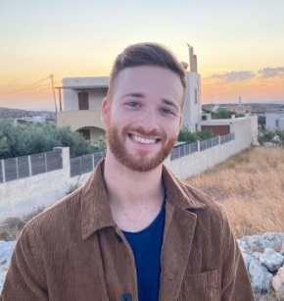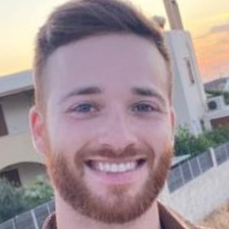The results of Image Alignment done on a picture of me to align the facial parts to be in the same location as the GAN’s training domain.

Before: After:

This is the way the images were aligned on the training data set FFHQ.

Results of 3.2 GAN Inversion-

In this section I tried to reconstruct an image of Barack Obama, the initial alignment for the image are as follows:

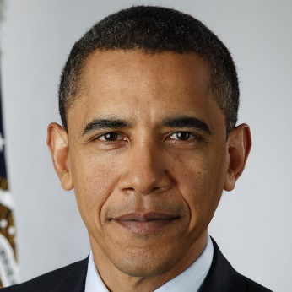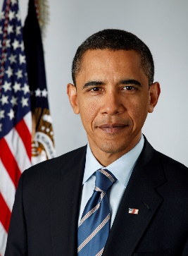

Following this initial alignment, I ran the invert image algorithm with the following results:

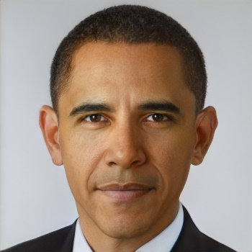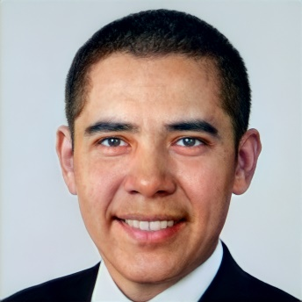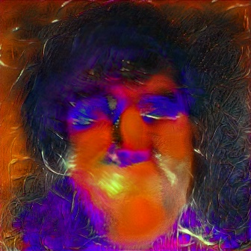Initial z after 200 steps after 500 steps

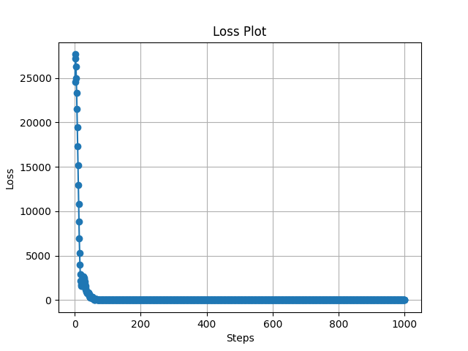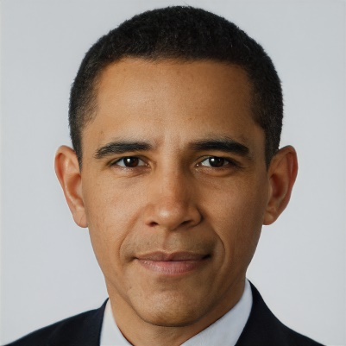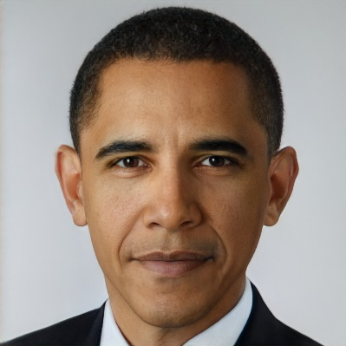after 800 steps final image

The hyper parameters used are 1000 steps for the optimization and the “latent dist reg weight” parameter set quit low to 0.001. since the image was very similar to the images in the training data set even for low regularization the generated image looks very similar to the original image. We can see that the most dramatic improvements are in the first few steps where we go from a completely unidentifiable image to one that looks human and within another 100 or so steps to an image that can be mistaken for the original without close inspection. this is further emphasised in the graph of the loss value as a function of the number of steps.

Results of 3.3.2 Image Colorization

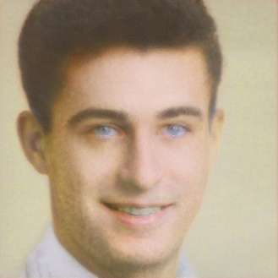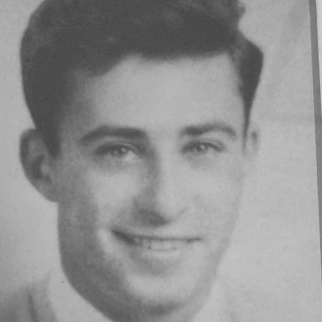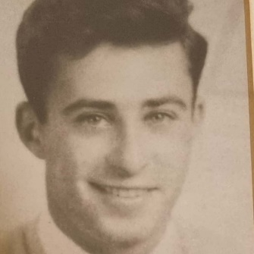 original grayscale colorized

For the task of Colorization, I chose a picture of my grandfather since its originally in grayscale and appears to be like the images from the training data set. I started by scanning loading and aligning the image, to begin with I tried to run the algorithm with the same hyperparameters as the last sections but kept getting unrealistic results, I tried running the algorithm for more steps but that didn’t help. The solution came from increasing the “latent dist reg weight” drastically. This parameter is used for regularization during the optimization process with higher values enforcing stricter adherence to the training data distribution, which lead to more realistic results.

## Results of 3.3.3 Image Inpainting

## original masked inpainted

For the task of inpainting, I chose a picture of Margo Robbie. I started by loading and aligning the image, like the last section I kept getting unrealistic results like red coloration in the masked portion of the image and again the solution came from increasing the “latent dist reg weight” but not as drastically, this along with lowering the number of steps which lowered the run time and computational resources needed led to more realistic results.

Conclusion

In conclusion, this exercise provided valuable insights into the application of Generative Adversarial Networks (GANs) for image reconstruction under various degradation modes and taught me the significant impact of different parameters on the quality and fidelity of reconstructed images. this exercise helped me understand the potential of GANs as powerful tools for image manipulation and reconstruction.  
On a personal note, the colorization section was emotional for me and my mother, my grandfather passed away when she was 20 and I was never able to meet him. Looking at a coloured image of him, even a reconstructed one, was almost like being face to face with him, so I wanted to sincerely say Thank you for that.